RESULTS SUMMARY
Insert title here

Author: Insert organisation (Year) Find project on OpenAid
PROJECT | Title: Insert text here
 | Partner: Insert text here
 | Country: Insert text here
 | Period: Insert text here

CHANGE | Insert text here

CONTEXT | Insert text here

CONTRIBUTION | Insert text here

IMAGES | Insert photo credit | Insert photo credit
See next page for more details
ADDITIONAL INFORMATION

ACTIVITIES | Insert text here

LESSONS | Insert text here

EVIDENCE | Insert text here

 | DOMAINS | Development strategy priorities: Strategic Sector Cooperation
 |  | Changes in the lives of people facing poverty, marginalisation or vulnerability | -
 |  | Changes in laws, policies and practices that affect people’s rights | -
 |  | Changes in the capacity of organisations and communities to support rights | X
 |  | Changes in partnerships and collaborations that support people’s rights | X
 |  | Changes in participation of groups facing poverty, marginalisation or vulnerability | -
 |  | Changes in local leadership of development and humanitarian work | -
STRATEGIC SECTOR COOPERATION (SSC)
Government-to-government cooperation, also known as Strategic Sector Cooperation (SSC) is a central instrument in Danish foreign policy, security policy and development cooperation. This involves Danish public authorities working with national partner authorities to build equal partnerships and form alliances.
It focuses on sharing expertise and experiences in peer-to-peer collaboration within policy development, regulation, planning, enforcement and implementation, including through public-private partnerships.
The objective of the SSC instrument is to help strengthen the capacity of the national partner authorities to improve framework conditions and the related product or service delivery to enhance their countries’ inclusive and sustainable social and economic development and green transition, and through this, to strengthen Denmark’s bilateral diplomatic relations, including green diplomacy, and pave the way for further engagement of the Danish private sector and use of Danish technology and knowledge on a commercial basis in the countries in the long-term. The SSC instrument focuses on sectors where Danish public authorities have knowledge and expertise that are in demand in partner countries and where Danish companies have relevant competitive solutions to offer.
DERIVED CO-BENEFITS | Bilateral relations | -
 | Economic diplomacy | -
 | Other development initiatives | -
 | Insert text here

SDGs | ☐  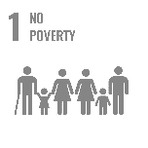 | ☐   | ☐   | ☐  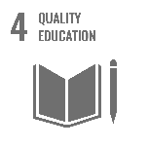 | ☐  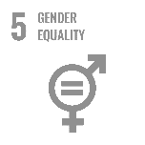 | ☐  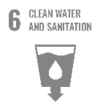
 | ☐   | ☐  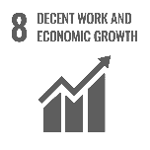 | ☐  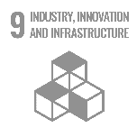 | ☐  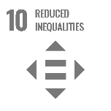 | ☐  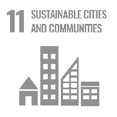 | ☐  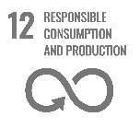
 | ☐   | ☐  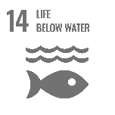 | ☐  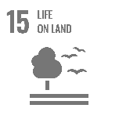 | ☐   | ☐  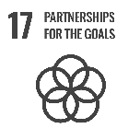

See next page for further guidance
GUIDANCE NOTE

This format consists of two overall sections: on page one, the results summary communicates results to an external audience using a brief summary of what has been achieved; while page two provides an opportunity to explain the background and evidence behind the claims made as part of the summary.

Page 1: Results summary
The results summary should outline of the overall change. This should be phrased in a clear and concise manner, focusing on the benefits for target groups or communities, and preferably start out by stating the overall key message as a one-line statement. It is thus important to prioritise what the key message should be and not attempt to describe every possible change that may have occurred.

Note that case studies should not describe all of the activities carried out during the implementation. Instead, it should focus on one or two key messages to be highlighted – which may also span several projects – and only outline activities to backup contributions to the highlighted change.

This can be illustrated as a “reverse funnel.” First, the “change” section introduces the overall results claim, which answers the “which.” Note that this is done before any details have been provided. Second, the “context” section outlines the problem being addressed by the project and the significance of the change. For example, by explaining “why” it benefits target groups or communities.

Finally, and lastly, the “contribution” section should provide examples to justify for “how” the intervention contributed to realising change. Note that this should focus on the plausible linkage between the change and intervention rather than describing details from activities. It is often useful to think of this as a reverse theory-of-change, i.e. “After we did X, then Y occurred, because of Z.”
Figure 1:
Reverse funnel for communication
Change – Results claim (Which?)
Context – Significance (Why?)
Contribution – Justification (How?)
First
Last

When reporting on SSC projects…
Unlike projects with direct service delivery to target groups, SSC projects also aim to build capacity for, and alliances with, national partner authorities. The overall change described on page 1 should therefore highlight benefits for the partner authority and its work for the wider society. This should include reflections on how the change contributes to a more inclusive and sustainable social and economic development in the country or a target community.

The derived co-benefits of the SSC could be part of the result summary, if deemed important for the realised overall change. This relates to areas such as strengthened diplomatic relations and/or better opportunities for Danish commercial solutions, contributing to the partner country’s inclusive and sustainable development. These aspects are also covered on page 3.

Page 2: Additional information
The second page should provide background and evidence for project’s contribution to change. It can also address technical issues that do not fit in the results summary. The section consists of the following sections:

- Activities: Whereas the “contribution” section on page one provides a brief summary of the project contributions to change, the “activities” section allows for more detail on the project design, organisation and underlying activities in support of the contributions made.

- Lessons: Describes lessons learned through the implementation. These should relate to the results claim or alternatively the project(s) as a whole. Please consider (1) novelty – i.e. whether the change represents something new – and (2) the potential to scale and/or build on lessons going ahead.

- Evidence: A narrative comparison between results claims and the underlying evidence. It should answer “X led to Y, because of Z,” although it does not need to be phrased this way. It is useful to include references to a few selected documents for further details. Please see guidelines for more.

- Domains and development strategy: Describes contributions to defined domains and the Danish development strategy. Please consider limiting the number of domains to a few selected ones.

When reporting on SSC projects…
Note that the “activities” section should include a short description and history of the SSC. Additionally, references to the domains and relevant area of the development strategy are already predefined in the format – and do therefore not need to be selected for SSC projects.

Page 3: Strategic Sector Cooperation (SSC)
While the first two pages describe the overall change, the third page outlines further details on the cooperation between Danish and national authority partners as part of the SSC approach. This includes:

- Derived co-benefits: This section allows a more detailed description of contributions to of the SSC instrument (see SSC Guidelines on amg.um.dk) and linkages to other development initiatives. Mark (X) in relevant areas.

- Sustainable Development Goals (SDGs): Mark relevant SDG(s) for the highlighted change.

