Template 12 - [DD/MM/YYYY]
Project Document Transition Phase

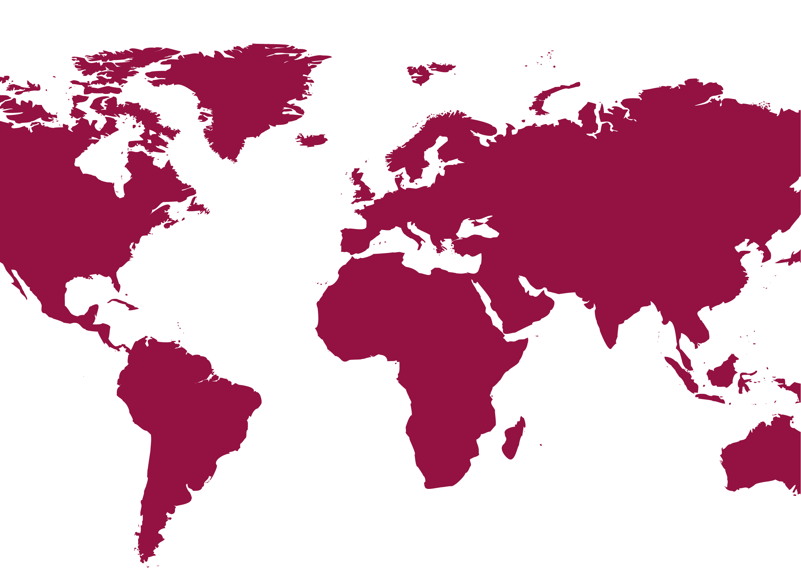
Strategic Sector Cooperation
[Name of Danish and Partner Authority(s)]

[Partner Country]

From [month/year] to [month/year]

[This application should be prepared by the Danish authority together with the partner authority with input from the Danish embassy in accordance with the SSC Guidelines (see Chapter 4). The document should be a maximum of three pages excl. annexes. All three overarching objectives of the SSC instrument do not have to be addressed in the Transition Phase. For example, if the partner authority, the Danish public authority, and the Danish embassy assess and agree that results can be achieved only in terms of wider bilateral cooperation, the Transition Phase should focus on this. Do note that all transition phases should have the social and economic development and green transition of the partner country as its overall objective.]
Background information

Project title |  | MFA File number:
Partner country
Transition phase duration | [Maximum 24 months.]
Total transition phase budget (DKK) | [Maximum DKK 1.5 million. Detailed budget in annex.]
Thematic focus | [Refer to relevant thematic focus areas of the framework programme, if applicable.]
Framework programme | Under an existing framework programme?  _Yes _No
Partner authority(s)  contact person | [Indicate partner organisation(s).]
Danish public authority
contact person
The Danish Embassy contact person

The objective of the Transition Phase is to maintain and further the results of the completed SSC project and cooperation amongst the partners without an SSC project.
1. Background and Results description
[Please describe the current situation at the end of the SSC project and the envisaged scenario to which the Transition Phase will bridge to. Include a description of the following:
- What are the key results of the SSC project: What are the strengthened and sustainable organisational abilities of the partner authority, i.e. the changed framework conditions and related product or service delivery; what is the outcome of the strengthened bilateral diplomatic relations; and what are the results of the further engagement of the Danish private sector, etc.?
- How will these results be sustained independently of the cooperation with the Danish authority?
- What is the envisaged cooperation scenario at the end of the Transition Phase? How will the outputs of the Transition Phase lead to this?
- How will the cooperation after the SSC project be maintained and by whom? Specifically, how will the results in terms of strengthened organisational abilities be consolidated? How will the bilateral diplomatic relations be maintained? How will inclusion of Danish commercial solutions to support the partner country’s social and economic development and green transition in the future be fostered?
- How does the future cooperation align with relevant national strategies within the intervention sector in the partner country? How does it link with priorities of the Danish public authority; the existing bilateral relations and priorities of Denmark in the country, including economic diplomacy; other Danish development engagements; and development engagements of the EU/other donors?]
2. project objective and results framework
Project objective | [The intended impact of the Transition Phase on 1) sustained capacity development, 2) wider bilateral diplomatic relations and/or 3) paving the way for further private sector engagement]

Output 1 |  | [Short-term result in the form of deliverables which result from Transition Phase project activities]
Output indicator
Baseline | Year |  | [Situation prior to the Transition Phase]
Annual target | Year 1 |  | [Intended situation after first year of implementation]
End target | Year 2 |  | [Intended situation after completion of the Transition Phase]
Output 2
Output indicator
Baseline | Year
Annual target | Year 1
End target | Year 2

[Insert a detailed workplan (see Template 3) of activities leading to the outputs. Examples of activities could be visits to partner country, workshops, joint activities on common agenda in international fora, follow-ups on demonstration projects, etc.]
3. management and organisation
[Please describe the management setup of the Transition Phase, including the management anchor in the Danish public authority, the partner authority, and the Danish Embassy, in addition to a description of the division of responsibilities.]
4. signatures

Danish public authority:  Name:  Title:  Date:  ---------------------------------------------------  Signature | Partner authority:  Name:  Title:  Date:  ---------------------------------------------------  Signature
5. Annexes
- Activities envisaged, their timing and who is responsible (Template 3)
- Transition phase budget (See the SSC Guidelines Chapter 6.3 and Template 4a)
- Transition Strategy Note (See the SSC Guidelines Chapter 4.1)

Project start will be the date of Danish MFA approval.

